**DAILY ONLINE ACTIVITIES SUMMARY**

|  |  |  |  |  |  |
| --- | --- | --- | --- | --- | --- |
| **Date:** | | **29 may 2020** | **Name:** | **KHATHEEJA SAFREENA** | |
| **Sem & Sec** | | **4th sem, 2nd year** | **USN:** | **4AL18CS037** | |
| **Online Test Summary** | | | | | |
| **Subject** | **OPERATING SYSTEMS (18cs43)** | | | | |
| **Max. Marks** | **30** | | **Score** | **29** | |
| **Certification Course Summary** | | | | | |
| **Course** | | **1.INTRODUCTION TO DIGITAL MARKETING.**  **2.MACHINE LEARNING WITH PYTHON**  **.** | | | |
| **Certificate Provider** | | **1.GreatLearning**  **2.Great Learning** | **Duration** | | **1)2.5 hours.**  **2) 10 hours.** |
| **Coding Challenges** | | | | | |
| **Problem Statement:2 program** | | | | | |
| **Status: Executed** | | | | | |
| **Uploaded the report in Github** | | | **Yes** | | |
| **If yes Repository.** | | | **[http://github.com/shafreenasharief/lockdown-coding](http://github.com/shafreenasharief/lockdown-coding" \o "http://github.com/shafreenasharief/lockdown-coding)**  **[https://github.com/shafreenasharief/Daily_Report](https://github.com/shafreenasharief/Daily_Report" \o "https://github.com/shafreenasharief/Daily_Report)**  **[http://github.com/shafreenasharief/locked-down--certification-course](http://github.com/shafreenasharief/locked-down--certification-course" \o "http://github.com/shafreenasharief/locked-down--certification-course)** | | |
| **Uploaded the report in slack** | | | **Yes** | | |

Online Test Details: (Attach the snapshot and briefly write the report for the same)

Certification Course Details: (Attach the snapshot and briefly write the report for the same)

Coding Challenges Details: (Attach the snapshot and briefly write the report for the same)

**ONLINE TEST SUMMARY**:

Today **OPERATING SYSTEMS (18cs43)** was conducted of first module. Total marks for the test was 30.

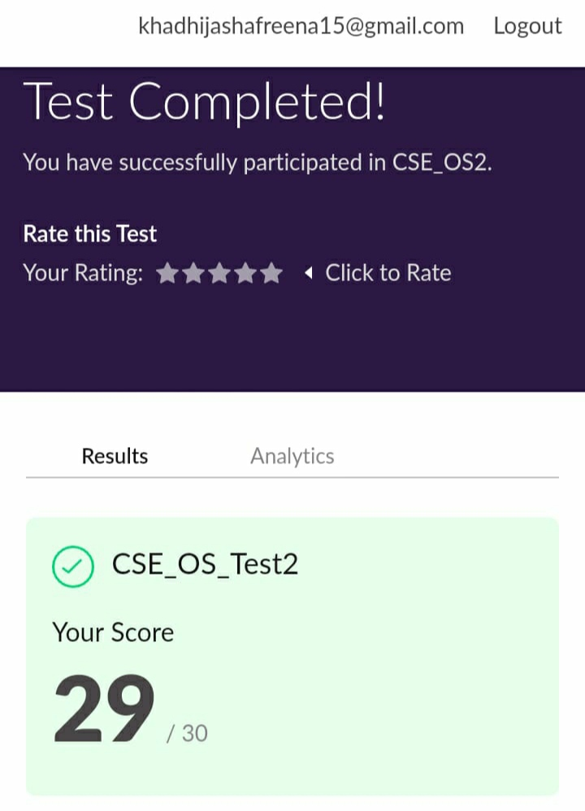

**ONLINE CERTIFICATION COURSES:**

**1. INTRODUCTION TO DIGITAL MARKETING.**

* **I'm doing certification course on INTRODUCTION TO DIGITAL MARKETING on great learning.The course is secluded for 2.5 hour.Today I completed 3 module which is what is customer audience, Types of ads.I attempted quiz which gave me a clear veiw about the topics that were thought and discussed.**
* **It consists of 10 modules including assessments.**



**2.MACHINE LEARNING WITH PYTHON**.

* Today I'm doing a course on MACHINE LEARNING WITH PYTHON. It is a 10 hours course. I completed 1 module. Which explains about introduction of python and it's Libraries. I attempted quiz which gave me a clear veiw about the topics that were thought and discussed.
* It consists of 30 modules including assessments.

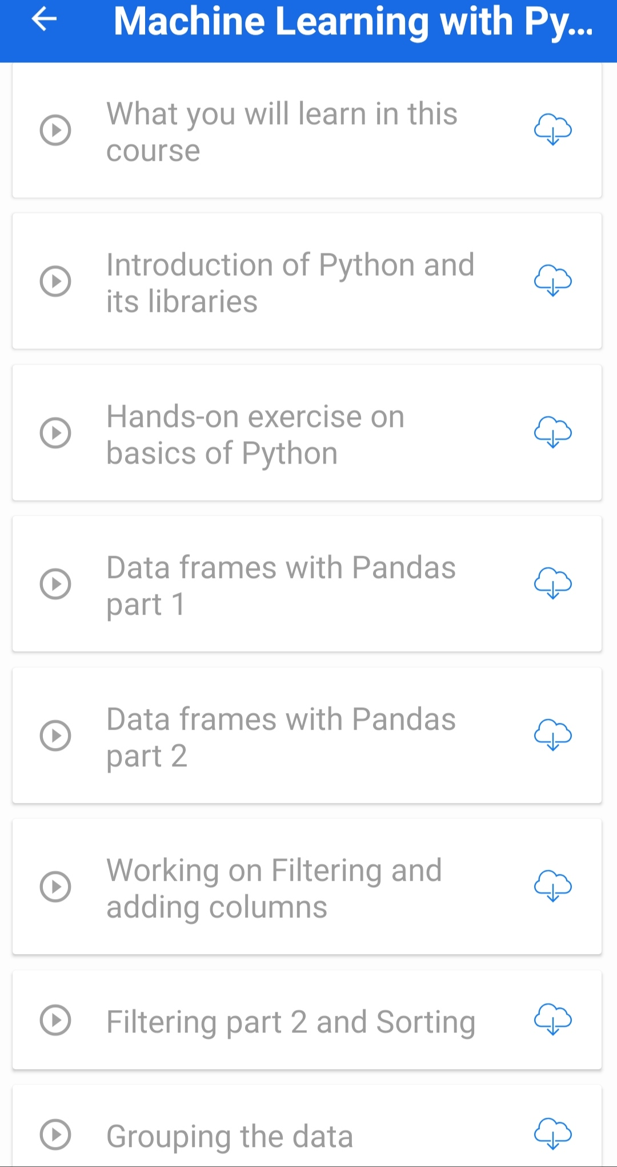

**CODING CHALLENGE:**

Today I solved 2 coding challenge,

1. [Write a C Program to generate first N Armstrong Numbers](https://github.com/orgs/alvas-education-foundation/teams/2nd-year/discussions/87)
2. [Write a Java program to Find size of the largest ‘+’ formed by all ones in a binary matrix](https://github.com/orgs/alvas-education-foundation/teams/2nd-year/discussions/86)

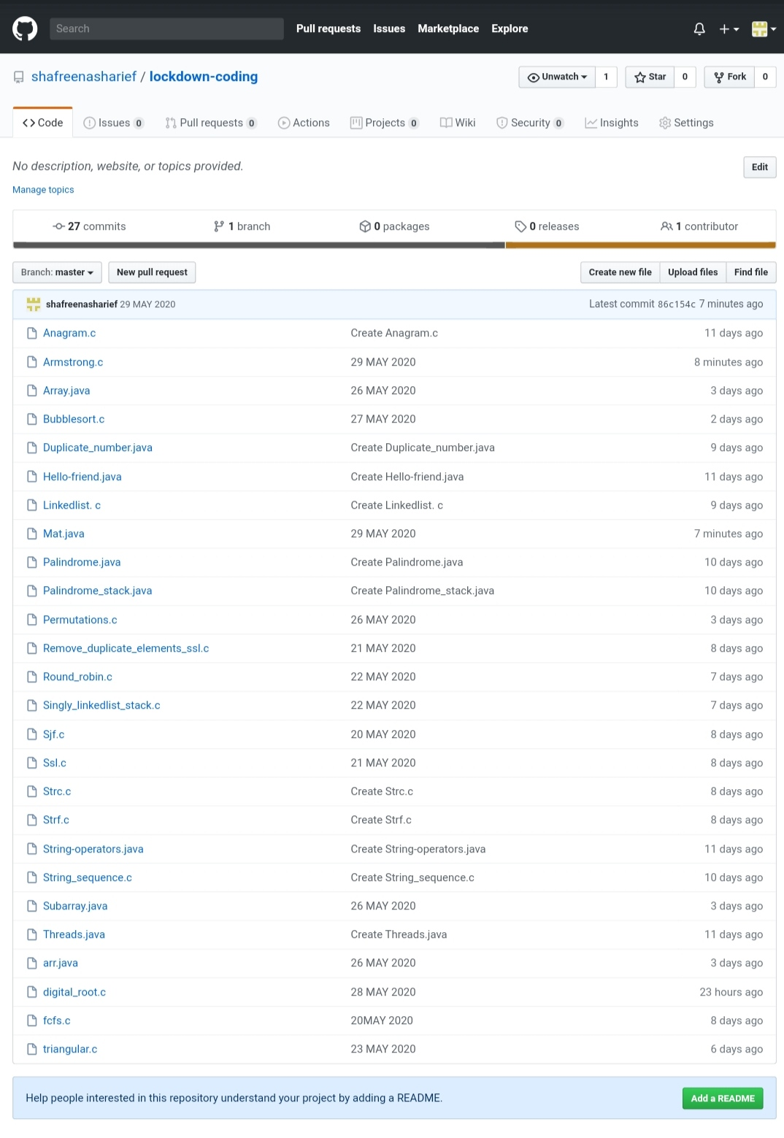

SOLUTION : I have uploaded the solution of the above 4 coding problems in my GitHub repository.

[http://github.com/shafreenasharief/lockdown-coding](http://github.com/shafreenasharief/lockdown-coding" \o "http://github.com/shafreenasharief/lockdown-coding)

[http://github.com/shafreenasharief/locked-down--certification-course](http://github.com/shafreenasharief/locked-down--certification-course" \o "http://github.com/shafreenasharief/locked-down--certification-course)

[http://github.com/shafreenasharief/Daily_Report](http://github.com/shafreenasharief/Daily_Report" \o "http://github.com/shafreenasharief/Daily_Report)